Advance Organizer

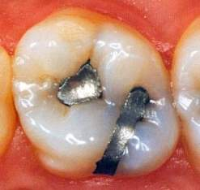

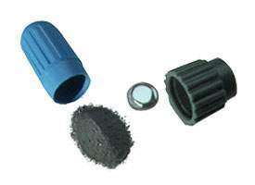

Week 4

Unit 3: Amalgam

MDA Chapter 43

**Smiley face icon with hands in a meditation positionQuestions to ask yourself before completing your required**

**reading.**

* Would you want an amalgam (silver) filling in your mouth?
* Would you want to work as a Dental Assistant for someone who uses amalgam as a restorative material?
* Do you think amalgam fillings are safe?
* Why don’t they just ban amalgam if people feel it is not safe?
* Can you think of anywhere else in the environment you can find mercury?

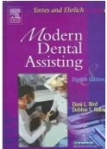**smiley face icon reading a bookRead pages 688-694 in your MDA**

Now that you have finished reading; go back and see if your answers to the above questions have changed. Be prepared to discuss the questions listed above in class on Tuesday.

**Complete the following activities to prepare yourself for class.**

<http://evolve.elsevier.com/productPages/s_1481.html>

Watch the Amalgam Video found under Dental Materials and answer the Video

Review Questions

smiley face icon playing cards  Chapter 43 Electronic Flashcards

smiley face icon reading a bookChapter 43 Practice Quiz

smiley place icon with glasses Complete the Mix and Match activity on page 32 of your study guide